**COVID-19 Detection using Cough Recordings \*\***

Project-I (18ME10024) report submitted to

Indian Institute of Technology, Kharagpur

In partial fulfillment for the award of the degree of

Bachelor of Technology (Hons.)

In

Mechanical Engineering

**By**

**Himanshu**

**(**18ME10024**)**

**Under the supervision of**

**Prof. Ram Babu Roy**



**Department of Mechanical Engineering**

**Indian Institute of Technology, Kharagpur**

**Autumn Semester,**

**November 22, 2021**

**DECLARATION**

I certify that

(a) The work contained in this report has been done by me under the guidance of my supervisor.

(b) The work has not been submitted to any other Institute for any degree or diploma.

(c) I have conformed to the norms and guidelines given in the Ethical Code of Conduct of the Institute.

(d) Whenever I have used materials (data, theoretical analysis, figures, and text) from other sources, I have given due credit to them by citing them in the text of the thesis and giving their details in the references. Further, I have taken permission from the copyright owners of the sources, whenever necessary.

Date: Himanshu

Place: IIT Kharagpur (18ME10024)



**DEPARTMENT OF INDUSTRIAL ENGINEERING**

**INDIAN INSTITUTE OF THECHNOLOGY, KHARAGPUR**

**KHARAGPUR-721302, INDIA**

***CERTIFICATE***

This is to certify that the project report entitled **“COVID-19**”** submitted by Himanshu (Roll No. 18ME10024) to Indian Institute of Technology, Kharagpur towards fulfillment of requirements for the award of degree of Bachelor of Technology (Hons.) in Mechanical Engineering is a record of bonafide work carried out by him/her under my/our supervision and guidance during Autumn Semester 2021-22.

**Prof. Ram Babu Roy**

**Rajendra Mishra School of Engineering Entrepreneurship**

**Indian Institute of Technology**

**Kharagpur, India**

**Date –**

**Place- IIT Kharagpur**

# Table of Index

COVID-19 Detection Using Cough Recordings

Table of Contents

**Type chapter title (level 1)1**

Type chapter title (level 2)2

Type chapter title (level 3)3

**Type chapter title (level 1)4**

Type chapter title (level 2)5

Type chapter title (level 3)6

## Abstract

## Introduction

## Literature Review

## Problem Definition

## Solution Methodology

## Data generation and Numerical Experiment

## Results and Sensitivity Analysis

## Conclusion and Future work

## References

# Abstract

COVID-19 was first identified on 7 January 2020 in Wuhan, China; since then, much technological advancement is already in place to identify COVID-19 patients. We present a COVID-19 cough classifier that would help in contactless detection of COVID-19 patients by analysing their audio cough samples. The report demonstrates five machine learning classification models and combines those models into an ensemble model with 26 dominant features. The proposed method has been examined on both COVID-19 positive and healthy individuals' cough recordings. The results are promising, scoring accuracy of 99.3%, a sensitivity of 99% on validation data with an Area under the ROC curve of 0.97, all while maintaining interpretability.

# Introduction

On 11 March 2020, World Health Organization (WHO) declared COVID-19 a global pandemic. COVID-19 is caused by SARS-CoV-2(Severe Acute Respiratory Syndrome Corona-Virus). It starts by infecting the mucous membranes within the throat and moves down the respiratory tract leading to the lungs, with coughing being a common symptom [1]. Cough sound contains underutilised pulmonary health information which can be used for analysis. Until 16 June 2021, more than 177 million cases confirmed COVID-19 infections in more than 200 countries. Based on World Health Organization (WHO) statistics, close to 3.8 million people passed away after getting infected by the virus [2].

Methods like X-rays and Chest CT scans have been used to differentiate between COVID-19 and non COVID-19 patients [4]. Furthermore, these methods suggest that COVID-19 affects the respiratory system in a distinctive way [5]. Therefore, vital information about the respiratory system and the pathologies involved are carried in the cough sounds [6].

AI has many applications in speech and audio analysis, which can be implemented in the screening and early discovery of the infected people process, which could help curb and decrease the number of infected people. A cough audio modelling can provide diagnostic leads by implementing various machine learning tools and algorithms with advanced feature extraction techniques and robust classification models. Given the requirement of identifying COVID-19 patients, Machine Learning algorithms are extensively used to distinguish between COVID-19 and non COVID-19 patients by analysing the cough patterns. This paper identifies the various characteristics/pattern of COVID-19 cough by performing specific feature extraction techniques.

Implementing a classification algorithm and capable hardware can process cough audio to decrease the strain on the chemical labs and avoid chemical and toxic waste. Results can be displayed almost immediately with the help of machine learning classification algorithms. This paper presents cough audio processing from patients and analyses the waveforms based on different parameters to classify the audio into a COVID-19 patient or a healthy person. In the classification part, we use the five most interpretable machine learning classification algorithms and provide the 25 dominant features to these five classifiers to obtain the result and make an ensemble model that would be the most appropriate classifier for realistic implementation of COVID-19 cough detection.

# Problem Definition

Since the identification of COVID-19, COVID-19 has increased at an uncontrollable rate. As we eagerly await new drug and vaccine discoveries, a highly effective method to regulate the deadly virus spread is the need of the hour. Researchers have found that frequent testing at scale can help reduce transmission of this deadly virus [3]. This has led to a dire necessity for screening and diagnostic solutions that can be implemented globally.

# Literature Review

This review attempts to summarize the vital studies in cough detection and identify diseases based on cough audio samples’ features like frequency, duration, and intensity. A review of the literature is provided hereunder, keeping in view the current technological advancements specific to the focus of this research. In recent years, numerous studies have suggested acoustic features to identify respiratory diseases in cough signals. Furthermore, conditions associated with the respiratory system can be detected using machine learning algorithms analysis. Machine learning algorithms can also process respiratory data and coughs to diagnose COVID-19 [8][11].

Abeyratne et al. [9] examined the differences in pneumonia, asthma and bronchitis coughs. This paper extracted features from the cough sound such as Mel Frequency Cepstrum Coefficients, Zero Crossing, Formant frequencies and non-Gaussianity score; performed feature selection based on the p-value of the features. The Logistic Regression Model trained on recordings from 91 subjects showed a sensitivity of 80% and specificity of 73% on the Validation set. They also provided evidence supporting the hypothesis that cough carries information on the state of the lower respiratory tract.

In the system proposed by Belkacem et al. [10], the cough recording is initially passed through a cough detection system, a source separation system and then features such as Shannon Entropy (SH), Zero Crossing Rate and Mel-Frequency Cepstral Coefficients are extracted from the recording which is then passed through Deep Neural Network (DNN). A logarithmic scaled Mel-spectrogram has also been used for feature extraction, passed through a fully convolutional network (FCN). The authors also designed a pipeline in MATLAB to analyze the cough recordings, which consists of computing Fast Fourier Transform (FFT), Signal energy to extracting the features aforementioned.

Chatrzarrin et al. [12] have listed preprocessing and feature extraction techniques obtained from cough signals to classify them into dry and wet coughs. In a study carried out by Vikrant Et al. [13], the cough sound signals of the patients were classified into different respiratory ailments using a Support Vector Machine (SVM) classifier with the extraction of 3 features. SVM classifier yields an accuracy of 98.9% with True Positive Rate (TPR) ranging from 94% to 100%. In another study carried out by Matos Et al. [14], the hidden Markov models (HMMs) have been used to detect cough sounds with the extraction of features like linear predictive coding (LPC) coefficients and Mel frequency cepstral coefficients (MFCC). The algorithm used in the paper was able to identify 82% of the events of coughing correctly.

Imran et al. have made an app to classify COVID-19 cough from an audio recording with precision close to 90% [16]. They used a model pre-trained on general sounds and then tuned on COVID-19 data. Their app uses a mediator to combine the prediction of a Deep Learning model that uses a Mel spectrogram, consists of a Convolutional Neural Network (CNN) and a Machine Learning model which uses Mel Frequency Cepstrum coefficients (MFCC) as features to generate predictions.

Sharma et al. [17] have created a database consisting of respiratory sounds like coughing, breathing, and voice known as Coswara for COVID-19 detection. The Random Forest (RF) model trained on Coswara data gave a mean accuracy of 70% for coughing. In the paper by Wang et al. [18], Voice Activity Detection (VAD) has been done based on the similarity of Cepstral Coefficients. The usage of MFCC has proven to be the most suitable method for VAD in a noisy background compared to other features.

# Methodology

A Dataset consisting of 1443 cough audio recordings out of which 111 were that of COVID-19 positive patients and 1340 were that of healthy individuals was obtained out of which 164 recordings are from University of Manchester [19] and the rest 1279 recordings are taken from Indian Institute of Science, Bangalore [17], which contains 1150 records from Indian citizens and 149 from the other countries.

# Audio Preprocessing

Our speech signals consist of a set of information. The determination and capturing of such time-varying characteristics would help us distinguish between a variety of coughs. For extracting these features, the cough recordings are in **.wav** format, and these waves are digitalized. These are converted into a one-dimensional array of digital values using sampling technique. These digital values represent the amplitude, frequency at that given instance. Here the sampling rate is fixed to 22050 for all the recordings.

As the dataset was imbalanced, SMOTE Data balancing technique was used. This technique has proven to be successful in the field of cough detection and classification [20].

## Feature Extraction

A total of 26 features were extracted from each cough recording, such as MFCC (first 20 coefficients), Chroma STFT, Root Mean Square Energy, Spectral Centroid, Spectral Roll off and Zero Crossing Rate. These features were extracted and used after careful literature review on cough identification, detection and classification [35][36][37].

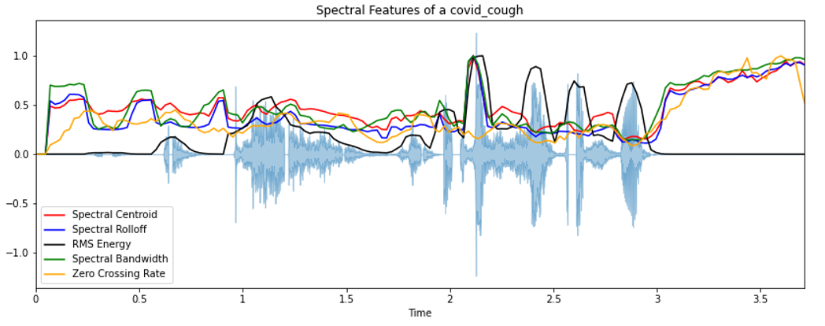

* *Zero Crossing Rate*

The Zero Crossing Rate (ZCR) [15] is the number of times the signal changes sign within a frame.

$$ZCR=\frac{1}{T-1}\sum_{t=1}^{T-1}{ }λ\left(s_{t}s_{t-1}<0\right)$$

Where $λ$ = 1 when the sign of $s_{t}$ and $s_{t-1}$ differ and $λ$ = 0 when the sign of $s_{t}$ and $s_{t-1}$ are same.

* *Chroma STFT*

A 12-element representation of spectral energy where the bins represent the 12 distinctive pitch classes used to study music (Semitone spacing) where each representation indicates how much energy each pitch class has. The figure below uses short term Fourier transformation in order to compute Chroma features. These features carry harmonic and melodic characteristics of the audio while being robust to changes in timbre.

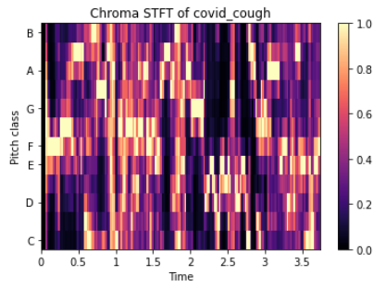

* *Mel Frequency Cepstral Coefficients (MFCCs)*

Mel frequency cepstral coefficients is a compact representation of the spectrum, a primary feature in research areas that includes audio signals ranging from detecting cough sounds to automatic speech recognition [21].

COVID-19 is said to cause inflammation of the upper airway and larynx [39]. This inflammation affects the flexibility of the vocal cords hence cause minor alterations in frequency. This alteration in frequency is captured using MFCC and hence is a vital component in detecting COVID-19 in cough sound.

MFCC represents the sound spectrum by converting the audio signal via a sequence of steps to imitate the vocal tract. MFCC can completely capture the characteristics of the spectrum and simulate the human's auditory function, whose approximation of speech is linearly spaced on the frequency scale. In filter-source theory, "the source is the vocal cords, and the filter represents the vocal tract."

Characteristics like shape and length of the vocal tract determine how sound is outputted from an individual, and the *Cepstrum coefficients* describe the filter, i.e., represent sound in a structured manner [22]

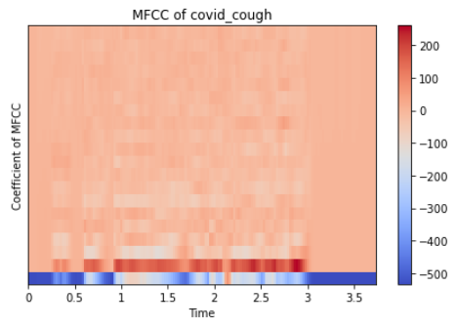

* *Root Mean Square Energy*

The energy of a signal is given by its total magnitude. For audio signals, this characterizes as to how loud the signal is. RMSE is the square root of the mean square (the average of the squares of the magnitude of the audio frames).[23]

$$\sqrt{\frac{1}{N}\sum_{n}{ }|x(n)|^{2}}$$

* *Spectral Roll off*

Spectral Roll-off is the frequency below which a specified percentage of the total spectral energy $N$ lies.

$$\text{Roll-off }=\sum_{k=b_{1}}^{d}{ }s_{k}=N\left(\sum_{k=b_{1}}^{b_{2}}{ }s_{k}\right)$$

where $s_{k}$ is the spectral value at bin $k$, $N$ is the percentile cutoff, and $b_{1}$ and $b_{2}$ are the band edges.

* *Spectral Centroid*

Spectral centroid is a measure to compute the "center of mass" of a given spectrum. It tells us about sound "brightness", which indicates the amount of high-frequency content in a sound. This is like a weighted mean:

$$f_{c}=\frac{\sum_{k}{ }S(k)f(k)}{\sum_{k}{ }S(k)}$$

where $S(k)$  is the spectral magnitude at frequency bin $k$ , $f(k)$  is the frequency at bin $k$ .

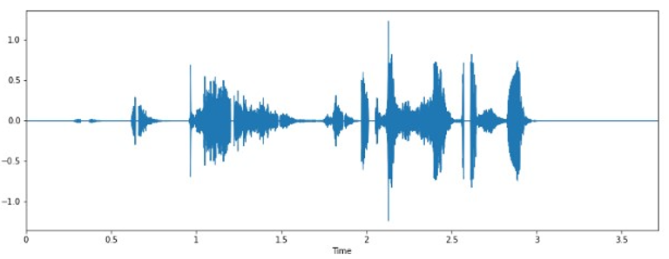

* *Spectral Bandwidth*

The spectral bandwidth is defined as the extent of the power transfer function around the center frequency [24].

$${\left(\sum_{k}{ }S(k){\left(f(k)-f_{c}\right)}^{p}\right)}^{\frac{1}{p}}$$

where $S(k)$  is the spectral magnitude at frequency bin $k$ , $f(k)$  is the frequency at bin $k$ , and $f_{c}$  is the spectral centroid.

# Classifier Architectures:

Five different classification models have been trained and tested on the dataset, keeping in mind the interpretability and explainability of the models:

*The idea here is to combine models with more explainability and more precision*

* *Logistic Regression*

We start with Logistic Regression. Logistic Regression has been found to be superior to other models such as Decision Trees, SVM, ANN in the field of Clinical Diagnosis [25]. The output of a logistic regression model is given below:

$$P=\frac{1}{1+e^{-(a+bx)}}$$

where $a$ and $b$ are the model parameters. $P$ is interpreted as probability and hence is used for binary classification. Hyperparameter tuning and Regularisation has been done on the Logistic Regression model to reduce overfitting. Three types of penalties were considered used to minimise the loss function: lasso, ridge and elastic net penalty (same weights of l1 and l2) and used AUC scores to compare the models.

* *Explainable Boosting Machine*

Explainable Boosting Machine [26] is a glass-box model created by Microsoft. It is a modification of a generalised additive model (GAM), also known as GA2M model [27] and is of the form:

$$g(E[y])=β_{0}+∑f_{i}\left(x_{i}\right)+∑f_{i,j}\left(x_{i},x_{j}\right)$$

Where $g$ is the link function that adapts the GAM to different settings such as Regression or classification, $f_{i}$  is a feature function that is learned by Explainable Boosting Classifier using machine learning techniques like Gradient Boosting and Bagging, $f_{i,j}$ represents the pairwise interaction function [29] of these features. Being an additive model, contributions of each feature to the prediction can be observed and hence these contributions can be understood, making the model completely interpretable.

* *Decision Tree Classifier*

Decision Tree Classifier [30] is a tree-structured classifier that replicates the human thinking ability while making a decision. The tree structure of the Decision Tree Classifier is ideal for capturing the interactions between the model's features, hence maintaining the interpretability of the model. The relation between outcome $\hat{y}$ and features $x$ is given by [31]:

$$\hat{y}=\hat{f}(x)=\sum_{m=1}^{M}{ }c_{m}I\left\{x∈R_{m}\right\}$$

Where $I\left\{x∈R_{m}\right\}$ is an identity function that returns 1 if $x$ is a subset of $R_{m}$ otherwise 0. If an instance falls into a leaf node $R_{l}$ , the predicted outcome is $\hat{y}=c_{l}$ , where $c_{l}$  is the average of all training instances in the leaf node $R_{l}$ . The selection of best attributes (also known as Attribute selection measure) is made using the Information Gain (or Entropy) technique, and the maximum depth of the tree is taken as 5.

* *Random Forest Classifier*

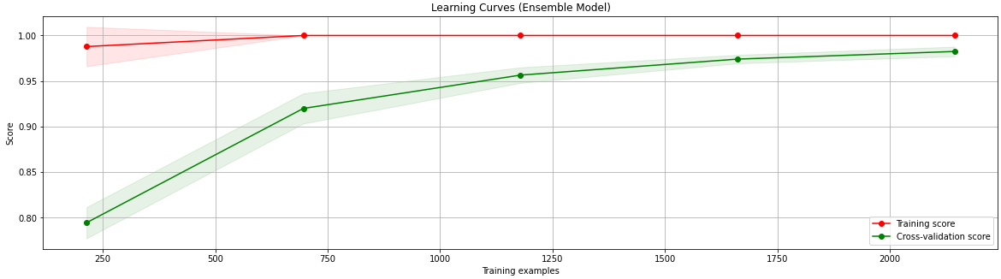Random Forest Classifier [31] is a supervised learning algorithm that creates, fits decision trees on randomly selected subsamples, and selects the best solution/prediction among these trees by voting and aggregation in classification and regression. These individual trees are generated using indicators such as information gain and the Gini index. Random Forest Classifier is also a good indicator of feature importance [32]. RFC also overcomes the overfitting caused by individual decision trees through the randomness of subsample and features’ selection.

* *XG Boost*

XG Boost [33] stands for Extreme Gradient Boosting. It is a supervised learning algorithm that implements a process called boosting which is an ensemble learning technique which corrects for deficiencies in previous models.

* *Ensemble Model*

Machine Learning algorithms have certain limitations and developing a model with high accuracy and sensitivity can be challenging. Hence building and combining multiple models can help boost these metrics.

Ensemble Learning is a machine learning approach to use multiple models to obtain better predictive performance than any single model’s performance.

Here Stacking Ensemble model has been used. Stacking [34] uses a “Level 1” classifier to combine multiple “Level 0” classification models. ‘’Level 0 or Base” Model are those models which fit on the training data and the predictions are made. “Level 1 or Meta” model is the model which learns how to best combine the predictions of the Base models.

Here, Logistic Regression, Explainable Boosting Machine, XG Boost, Decision Tree and Random Forest Classifier has been used as “Level 0” models. Random Forest Classifier has been used as the “Level 1” model.

# Results and Discussion:

The table below compares the different classification models' results using Accuracy, Precision, Recall, and F1 Score metrics. These metrics are for the detection of COVID positive labels. The results from the ensemble model show that cough sound can be used to detect COVID-19. The addition of more data could improve the models' sensitivity.

The table shows that the Ensemble Model exhibits the best performance, with auROC of 0.974, corresponding accuracy of 98% with Precision and Recall of 97% each.

The most straightforward metric to understand here is accuracy. Accuracy is the ratio of correct predictions to the total number of predictions. In this case, we do need a model with high accuracy, but it is important to note that we also need to ensure that the coughs of a COVID positive patient are not wrongly labelled. This brings us to the metrics: Recall and Precision, where Recall is the measure of the Total True positives (in this case COVID positive patients' cough) detected by the model and Precision is the ratio of true positives to all the Positives. In this case, we need a model which would:

* Detect all the COVID positive patients' coughs correctly
* Differentiate between a COVID positive and a healthy patients' cough

Now among Recall and Precision, we need to prioritize a metric to help us compare various models. If Precision is taken as the metric, the model will differentiate between the different types of coughs, but there is a possibility that a COVID positive patient's cough is wrongly labelled as healthy, which can cause further problems as that patient will now be considered as healthy and can further spread the virus.

|  |  |  |  |  |
| --- | --- | --- | --- | --- |
| **Classifier** | **Accuracy** | **Precision** | **Recall** | **F1-Score** |
| Decision Tree | 72% | 68% | 80% | 74% |
| EBM | 88% | 84% | 92% | 88% |
| Logistic Regression | 70% | 69% | 72% | 70% |
| RFC | 95% | 97% | 96% | 95% |
| XGB | 95% | 93% | 97% | 95% |
| **Ensemble Model** | **98%** | **97%** | **98%** | **98%** |

Using Recall ensures that all the specific label (COVID positive cough here) data points are correctly identified. Using Recall would also mean that certain Healthy coughs could be wrongly labelled as COVID positive coughs, but this inaccurate labelling will not lead to the problems encountered while using Precision as the metric because now there will not be a further spread of the virus as all the COVID patients are identified.

Hence, Recall is the correct metric for evaluating the models used for detecting COVID positive patients, and a Recall of 1 would be ideal for such a model.

Based on the above result, Ensemble Model performs better than the rest of the classifiers with a Recall of 0.98, while Random Forest and Ensemble both that the same Precision of 0.97. The figure below compares the area under Receiver Operating Characteristics of various models.

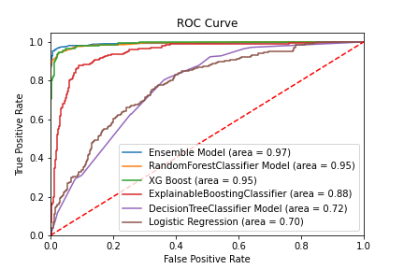

Another way of evaluating various models is the auROC. An ROC curve (receiver operating characteristic curve) is a graph showing the performance of a classification model at all classification thresholds. The Area Under the Curve (AUC) is the measure of the ability of a classifier to discriminate between classes; it is used to summarize the ROC curve. The higher the AUC, the better the model is at differentiating between the two classes.

# Conclusion and Discussion:

In this summary, a pipeline for the detection of COVID-19 in cough has been made. This pipeline includes processing cough sound, signal processing, feature extraction, training individual and ensemble classifiers, and classifying the cough sound. Feature extraction had a significant impact on the model, so much time was spent on ensuring the most negligible data loss. Small and unclean dataset

Future works include:

* Creating an App to increase the social impact of the model
* *installing* in devices like Google Home, Amazon Alexa
* Using the same idea for detecting other diseases
* Training the model on bigger datasets

## Using other feature extraction techniques to further make the model better. This model will not be an exact replacement of the current testing techniques, but will certainly prove to be a preliminary diagnostic tool.

# References:

[1] Mouawad, P., Dubnov, T. & Dubnov, S. Robust Detection of COVID-19 in Cough Sounds. *SN COMPUT. SCI.* **2,**34 (2021). <https://doi.org/10.1007/s42979-020-00422-6>

[2] [Online]. Available: <https://www.worldometers.info/coronavirus/> [Accessed 16 June 2021].

[3] Kucharski, A. J., Klepac, P., Conlan, A. J., Kissler, S. M., Tang, M. L., Fry, H., ... & Simons, D. (2020). Effectiveness of isolation, testing, contact tracing, and physical distancing on reducing transmission of SARS-CoV-2 in different settings: a mathematical modelling study. *The Lancet Infectious Diseases*, *20*(10), 1151-1160.

[4] Alafif, T., Tehame, A. M., Bajaba, S., Barnawi, A., & Zia, S. (2021). Machine and deep learning towards COVID-19 diagnosis and treatment: survey, challenges, and future directions. *International Journal of Environmental Research and Public Health*, *18*(3), 1117.

[5] Huang, C., Wang, Y., Li, X., Ren, L., Zhao, J., Hu, Y., ... & Cao, B. (2020). Clinical features of patients infected with 2019 novel coronavirus in Wuhan, China. *The lancet*, *395*(10223), 497-506.

[6] Rudraraju, G., Palreddy, S., Mamidgi, B., Sripada, N. R., Sai, Y. P., Vodnala, N. K., & Haranath, S. P. (2020). Cough sound analysis and objective correlation with spirometry and clinical diagnosis. *Informatics in Medicine Unlocked*, *19*, 100319.

[7] Vrindavanam, J., Srinath, R., Shankar, H. H., & Nagesh, G. (2021, April). Machine Learning based COVID-19 Cough Classification Models-A Comparative Analysis. In *2021 5th International Conference on Computing Methodologies and Communication (ICCMC)* (pp. 420-426). IEEE.

[8] Deshpande, G., & Schuller, B. (2020). An overview on audio, signal, speech, & language processing for covid-19. *arXiv preprint arXiv:2005.08579*.

[9] Abeyratne, U. R., Swarnkar, V., Setyati, A., & Triasih, R. (2013). Cough sound analysis can rapidly diagnose childhood pneumonia. *Annals of biomedical engineering*, *41*(11), 2448-2462.

[10] Belkacem, A. N., Ouhbi, S., Lakas, A., Benkhelifa, E., & Chen, C. (2021). End-to-End AI-Based Point-of-Care Diagnosis System for Classifying Respiratory Illnesses and Early Detection of COVID-19: A Theoretical Framework. *Frontiers in Medicine*, *8*, 372.

[11] Schuller, B. W., Schuller, D. M., Qian, K., Liu, J., Zheng, H., & Li, X. (2021). COVID-19 and Computer Audition: An Overview on What Speech & SoundAnalysis Could Contribute in theSARS-CoV-2 Corona Crisis. Frontiers in Digital Health, 3, 14.

[12] Chatrzarrin, H., Arcelus, A., Goubran, R., & Knoefel, F. (2011, May). Feature extraction for the differentiation of dry and wet cough sounds. In 2011 IEEE international symposium on medical measurements and applications (pp. 162-166). IEEE.

[13] Bhateja, V., Taquee, A., & Sharma, D. K. (2019, November). Pre-processing and classification of cough sounds in noisy environment using SVM. In 2019 4th International Conference on Information Systems and Computer Networks (ISCON) (pp. 822-826). IEEE.

[14] Matos, S., Birring, S. S., Pavord, I. D., & Evans, H. (2006). Detection of cough signals in continuous audio recordings using hidden Markov models. IEEE Transactions on Biomedical Engineering, 53(6), 1078-1083.

[15] Bachu, R. G., Kopparthi, S., Adapa, B., & Barkana, B. D. (2010). Voiced/unvoiced decision for speech signals based on zero-crossing rate and energy. In Advanced techniques in computing sciences and software engineering (pp. 279-282). Springer, Dordrecht.

[16] Imran, A., Posokhova, I., Qureshi, H. N., Masood, U., Riaz, M. S., Ali, K., ... & Nabeel, M. (2020). AI4COVID-19: AI enabled preliminary diagnosis for COVID-19 from cough samples via an app. Informatics in Medicine Unlocked, 20, 100378.

[17] Sharma, N., Krishnan, P., Kumar, R., Ramoji, S., Chetupalli, S. R., Ghosh, P. K., & Ganapathy, S. (2020). Coswara--A Database of Breathing, Cough, and Voice Sounds for COVID-19 Diagnosis. arXiv preprint arXiv:2005.10548.

[18] Wang, H., Xu, Y., & Li, M. (2011, August). Study on the MFCC similarity-based voice activity detection algorithm. In 2011 2nd International Conference on Artificial Intelligence, Management Science and Electronic Commerce (AIMSEC) (pp. 4391-4394). IEEE.

[19] Dunne, Robert (2020), “COVID-19 CNN MFCC classifier”, Mendeley Data, V1, doi: 10.17632/ww5dfy53cw.1

[20] Windmon, A., Minakshi, M., Bharti, P., Chellappan, S., Johansson, M., Jenkins, B. A., & Athilingam, P. R. (2018). Tussiswatch: A smart-phone system to identify cough episodes as early symptoms of chronic obstructive pulmonary disease and congestive heart failure. IEEE journal of biomedical and health informatics, 23(4), 1566-1573.

[21] Han, W., Chan, C. F., Choy, C. S., & Pun, K. P. (2006, May). An efficient MFCC extraction method in speech recognition. In 2006 IEEE international symposium on circuits and systems (pp. 4-pp). IEEE.

[22] Abushakra, A., Faezipour, M., Abumunshar, A., & Patra, P. (2012). Breathing Movement Classification Using MFCCs. .

[23] [Online]. <https://rramnauth2220.github.io/blog/posts/code/200525-feature-extraction.html>

[24] Liu, Z., Huang, J., Wang, Y., & Chen, T. (1997, June). Audio feature extraction and analysis for scene classification. In Proceedings of First Signal Processing Society Workshop on Multimedia Signal Processing (pp. 343-348). IEEE.

[25] Botha, G. H. R., Theron, G., Warren, R. M., Klopper, M., Dheda, K., Van Helden, P. D., & Niesler, T. R. (2018). Detection of tuberculosis by automatic cough sound analysis. Physiological measurement, 39(4), 045005.

[26] Nori, H., Jenkins, S., Koch, P., & Caruana, R. (2019). Interpretml: A unified framework for machine learning interpretability. arXiv preprint arXiv:1909.09223.

[27] Hastie, T., & Tibshirani, R. (1987). Generalized additive models: some applications. Journal of the American Statistical Association, 82(398), 371-386.

[28] Lou, Y., Caruana, R., Gehrke, J., & Hooker, G. (2013, August). Accurate intelligible models with pairwise interactions. In Proceedings of the 19th ACM SIGKDD international conference on Knowledge discovery and data mining (pp. 623-631).

[29] Lou, Y., Caruana, R., Gehrke, J., & Hooker, G. (2013, August). Accurate intelligible models with pairwise interactions. In Proceedings of the 19th ACM SIGKDD international conference on Knowledge discovery and data mining (pp. 623-631).

[30] Patel, H., & Prajapati, P. (2018). International Journal of Computer Sciences and Engineering Open Access. Int. J. Comput. Sci. Eng, 6(10).

[31] Molnar, Christoph. "Interpretable machine learning. A Guide for Making Black Box Models Explainable", 2019. <https://christophm.github.io/interpretable-ml-book/>.

[32] Breiman, L. (1996). Bagging predictors. Machine learning, 24(2), 123-140.

[33] Chen, T. (2016). Guestrin, C.: XGBoost: A Scalable Tree Boosting System. In Proceedings of the 22nd ACM SIGKDD International Conference on Knowledge Discovery and Data Mining (KDD’16) (pp. 785-794).

[34] Ting, K. M., & Witten, I. H. (1997). Stacked Generalization: when does it work?.

[35] Pramanik, A., & Raha, R. (2012, October). Automatic Speech Recognition using correlation analysis. In 2012 World congress on information and communication technologies (pp. 670-674). IEEE.

[36] Al-Khassaweneh, M., & Bani Abdelrahman, R. E. (2013). A signal processing approach for the diagnosis of asthma from cough sounds. Journal of medical engineering & technology, 37(3), 165-171.

[37] Boyanov, B., & Hadjitodorov, S. (1997). Acoustic analysis of pathological voices. A voice analysis system for the screening of laryngeal diseases. IEEE Engineering in Medicine and Biology Magazine, 16(4), 74-82.

[38] [Online] <https://developers.google.com/machine-learning/crash-course/classification/roc-and-auc>

[39] [Online] <https://health.clevelandclinic.org/what-is-covid-19-voice-and-what-causes-it/>